UNIVERSITY RECORD MANAGEMENT SYSTEM
Database Connection Assignment
Group B
Submitted to
The University of Liverpool
Master of Science (Various)
Databases and Information Systems
Final Group Assignment
Word Count: 1335
20/07/2026

Table of Contents
1. Introduction 3
2. Requirements and group organisation 3
3. Database design and module foundations 3
4. Implementation and interface 5
5. Query functionality 5
6. Testing, validation and reflection 6
7. Conclusion 6
Reference list 7
Appendix A: Interface and query evidence 8
Appendix B: Testing results 24

1. Introduction
This report evaluates the group's University Record Management System, a Streamlit and SQLite application developed for the Database Connection Assignment. The brief required a university records database, dummy data, a Python interface and at least five queries executed from within the code. The current repository satisfies this through a normalised SQLite database, a browser-based interface, query pages, reports, SQL scripts and meeting records. In line with Week 1's emphasis on database systems as organised structures for storing and retrieving data, the project treats the database as the main source of truth rather than as a static spreadsheet (Foster and Godbole, 2016).
The implementation also reflects the practical principle that stored data should be reusable, documented and auditable. Hart et al. (2016) argue that durable digital data depends on deliberate organisation and future readability. This is demonstrated by the repository's database folder, source-code folder, meeting-minutes folder and test folder, which separate data, interface logic and evidence of collaboration.

2. Requirements and group organisation
The assignment required the group to construct a database in a DBMS, populate it with dummy data, build a simple interface, execute at least five different database queries through Python, follow PEP 8 coding expectations and submit a 1,000-1,500 word report with an ERD and video demonstration. The repository addresses these requirements using SQLite for the DBMS and Streamlit for the Python interface. SQLite is suitable for this coursework because the database is portable as a single file, while Streamlit enables a usable interface without requiring a full web-development stack.
Project organisation was structured around project management, database design, software development and testing responsibilities. The project-management function coordinated the repository, reviewed progress, supported report quality and contributed to database-design review. The database-design work is reflected in the ERD and implementation scope, while the software interface and testing work are evidenced by the runnable Streamlit pages and query outputs shown in Appendix A.

3. Database design and module foundations
The supplied ERD shows a normalised logical design covering academic structure, course delivery, assessment, staff, students, research activity, committees, publications and funding. It follows Codd's (1970) relational model by decomposing the problem into linked relations with identifiable keys, instead of storing multiple values inside one field. This directly responds to the brief's warning that plural attributes such as grades, disciplinary records, qualifications and publications should not be captured in a single cell.
The design uses bridge tables to resolve many-to-many relationships. For example, ENROLLMENT links students to course offerings, TEACHING_ASSIGNMENT links lecturers to offerings, LECTURER_EXPERTISE links lecturers to research areas, and PROJECT_TEAM links people to research projects. This mirrors Week 2's focus on relational query logic because useful results are obtained by joining relations rather than duplicating information across records (Garcia-Molina, Ullman and Widom, 2013).

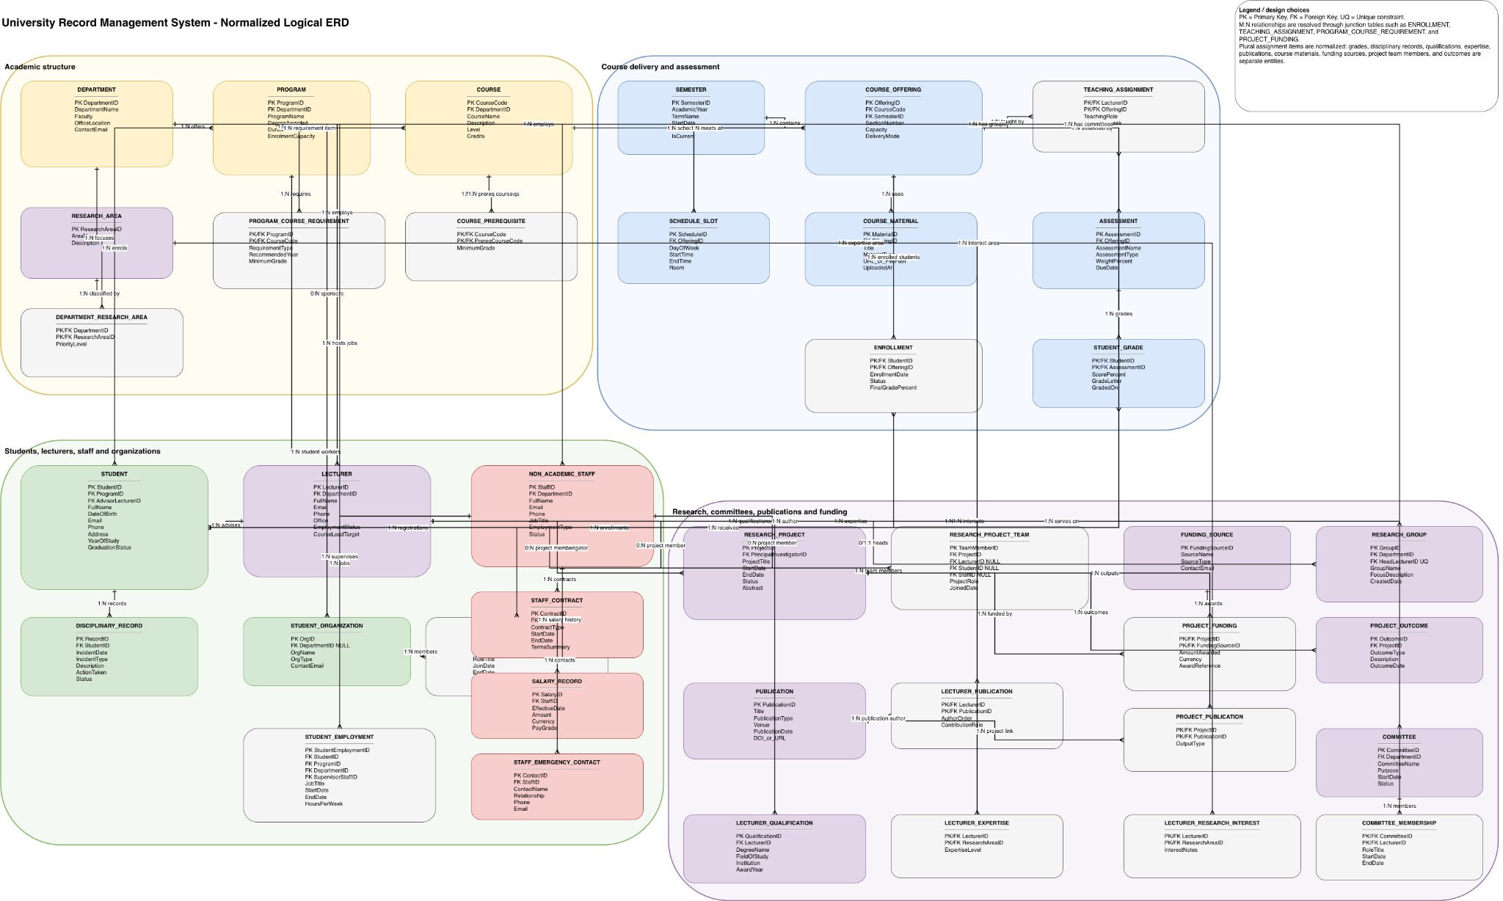
Figure 1. University Record Management System normalised logical ERD.

The physical database file, database/university.db, implements a smaller working subset of the full logical ERD. It contains 40 tables, including faculties, departments, programmes, courses, semesters, course offerings, teaching assignments, enrolments, lecturer expertise, publications, research projects and non-academic staff. The current data includes three faculties, three departments, three programmes, five lecturers, seven students, seven courses, nine course offerings, 11 teaching assignments, 14 enrolments, five publications, four research projects and four non-academic staff records. This is sufficient for the application queries while preserving a path for further expansion.
An information-architecture theme is visible in the separation between student-facing academic data, staff data, research data and report outputs. Sherman (2015) emphasises that analytical value depends on organising information so that users can navigate it meaningfully. The dashboard, entity pages and reports apply this principle by presenting filtered views of the same underlying data.

4. Implementation and interface
The application entry point is src/Dashboard.py, with additional pages under src/pages for Students, Lecturers, Non-Academic Staff, Courses, Departments, Programs, Research Projects, Query Builder and Reports. The shared database access layer in src/urms/database.py connects to database/university.db and exposes compatibility views for the front end. This satisfies the core database connection requirement, while the sidebar visibly confirms that the interface is connected to the database rather than only using temporary demo data.
The system is closer to a transactional record-management application rather than a full analytical warehouse as students, lecturers, courses and enrolments are retrieved through operational queries, while the Reports page adds lightweight summaries. This distinction between OLTP-style record handling and OLAP-style analysis is important when selecting database structures and query patterns (IBM, 2021). Although full authentication and role-based authorisation are outside the current scope, the relational schema supports integrity through keys and controlled relationships, reflecting the ACID and recovery principles discussed by Haerder and Reuter (1983).
The interface also demonstrates data visualisation learning as the tables, filters, expandable department details and report cards make database outputs understandable for non-technical users, which aligns with the argument that visualisation should improve interpretation rather than merely decorate results (Kochhar, Meenakshi and Dubey, 2020). Screenshots in Appendix A show these views, including the dashboard, entity pages, reports and query outputs.

5. Query functionality
The key assessment requirement is met through the Query Builder page and src/urms/queries.py. The interface provides ten predefined queries, each with a name, parameter controls, SQL statement and binding function. The implemented queries include students by department, students enrolled in a course, courses taught by a lecturer, lecturers in a research area, students by year of study, research projects by status, high-performing students, course enrolment counts, publications since a date and staff by employment type. The screenshots in Appendix A provide evidence that several of these queries were executed successfully through the user interface, with results and SQL statements displayed.
The query layer uses parameterised SQL, which is important because it separates user inputs from executable SQL text. In practical terms, the selected department, course, lecturer or research area becomes a bound parameter rather than a string concatenated into the query. This improves reliability and supports maintainability, both of which are emphasised in standard database texts (Silberschatz, Korth and Sudarshan, 2019). A connection-management theme is also reflected in the decision to centralise database access in a shared module rather than opening separate ad hoc connections throughout the pages (Aboagye, 2020).
Interface query | Database concepts demonstrated | Evidence
Students by Department | JOIN and optional filtering across STUDENT and PROGRAM | Figure A10 and Figure A11
Students Enrolled in a Course | Course offering and enrolment relationship with grades | Figure A13
Courses Taught by a Lecturer | Teaching assignment bridge table | Figure A14
Lecturers in a Research Area | Lecturer expertise and research-area relationship | Figure A15
Students by Year of Study | Parameterized filtering and displayed SQL | Figure A16
Reports page | Summarised reporting view over staff/employment data | Figure A11

6. Testing, validation and reflection
Testing was performed through two complementary routes: repository tests and manual interface validation. The tests folder includes database and query-focused test files, while the screenshots show that the live application can open the SQLite database, display entity records, run queries and generate reports. This combination is appropriate because the assignment assesses both the underlying database connection and the visible user-facing query interface.
The project also shows the limits of the current implementation. It is not a production-grade university system because it does not yet include authentication, complete CRUD workflows, role-based permissions, audit logging or large-scale performance testing. However, that limitation is proportionate to the assignment, which prioritises database construction, dummy data, Python connectivity and query execution. Further possible future extensions include semantic search could improve discovery across publications and research projects, while a graph database could model dense relationships between students, supervisors, committees and research areas (Ma and Yuan, 2013; Robinson, Webber and Eifrem, 2015; Lin et al., 2021).

7. Conclusion
Overall, the project demonstrates the main module learning outcomes in a practical system. The ERD provides a normalised logical design, the SQLite database implements the core entities and relationships, the Streamlit app connects to the database, and the Query Builder executes more than five parameterised SQL queries. The final product is therefore a functional record-management prototype that links database theory, information architecture, query logic, interface design and testing evidence.

Reference list
Aboagye, M. (2020) ‘Improve database performance with connection pooling’, Stack Overflow Blog.
Codd, E.F. (1970) ‘A relational model of data for large shared data banks’, Communications of the ACM, 13(6), pp. 377–387.
Foster, E.C. and Godbole, S. (2016) ‘Introduction to database systems’, in Foster, E.C. and Godbole, S. (eds) Database Systems: A Pragmatic Approach. Berkeley, CA: Apress, pp. 3–14.
Garcia-Molina, H., Ullman, J.D. and Widom, J. (2013) ‘Chapter 5: Algebraic query and logical languages’, in Database Systems: The Complete Book. Harlow: Pearson Education Limited, pp. 199–236.
Haerder, T. and Reuter, A. (1983) ‘Principles of transaction-oriented database recovery’, ACM Computing Surveys, 15(4), pp. 287–317.
Hart, E.M. et al. (2016) ‘Ten simple rules for digital data storage’, PLOS Computational Biology, 12(10), e1005097.
IBM (2021) ‘OLAP vs. OLTP: What’s the difference?’, IBM Think.
Kochhar, D., Meenakshi, S.P. and Dubey, S. (2020) ‘Applications of visualization techniques’, in Anouncia, S.M., Gohel, H.A. and Vairamuthu, S. (eds) Data Visualization: Trends and Challenges Toward Multidisciplinary Perception. Singapore: Springer Singapore, pp. 93–114.
Lin, F. et al. (2021) ‘Power quality monitoring and its visualization application based on graph database’, in 2021 6th Asia Conference on Power and Electrical Engineering (ACPEE), pp. 1160–1167.
Ma, X. and Yuan, B. (2013) ‘Enhancing software search with semantic information from Wikipedia’, in Li, J. et al. (eds) Semantic Web and Web Science. New York, NY: Springer, pp. 1–9.
Robinson, I., Webber, J. and Eifrem, E. (2015) Graph Databases. 2nd edn. Sebastopol, CA: O’Reilly Media.
Sherman, R. (2015) ‘Chapter 5: Information architecture’, in Sherman, R. (ed.) Business Intelligence Guidebook: From Data Integration to Analytics. Boston, MA: Morgan Kaufmann, pp. 85–106.
Silberschatz, A., Korth, H.F. and Sudarshan, S. (2019) Database System Concepts. 7th edn. New York: McGraw-Hill.

Appendix A: Interface and query evidence
The following figures are screenshots captured from the running Streamlit application. They evidence the connected database, entity pages, query outputs and reporting screens discussed in the report.
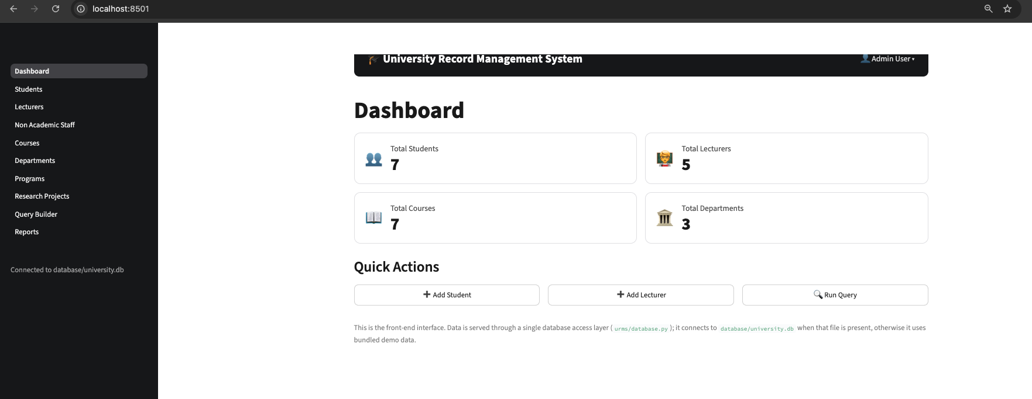
Figure A1. Dashboard overview showing live connection to database/university.db and core entity totals.

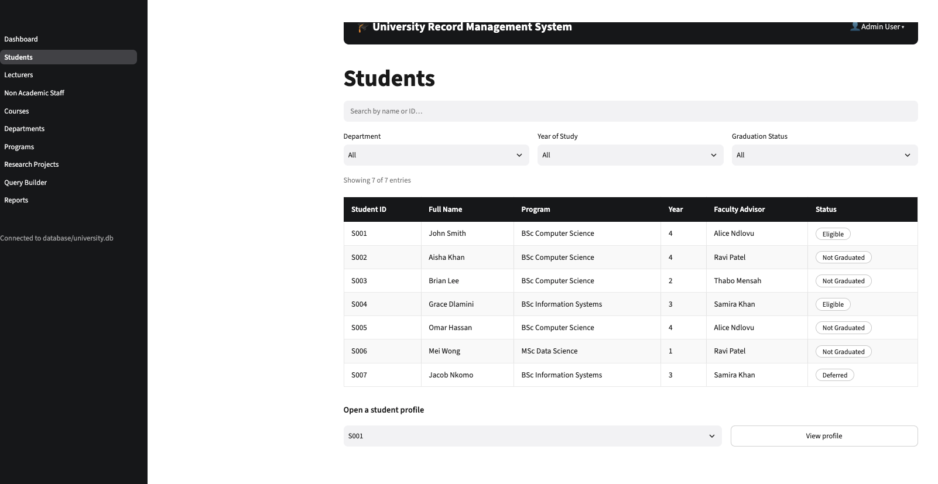
Figure A2. Students page showing student records, programme, year, advisor and graduation status.

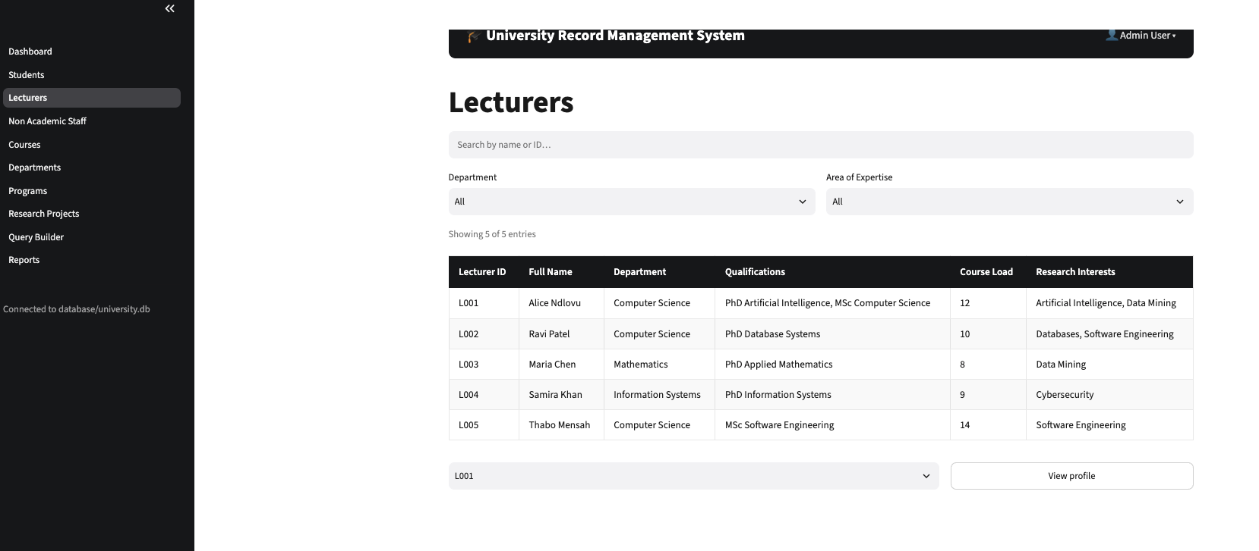
Figure A3. Lecturers page showing department, qualifications, course load and research interests.

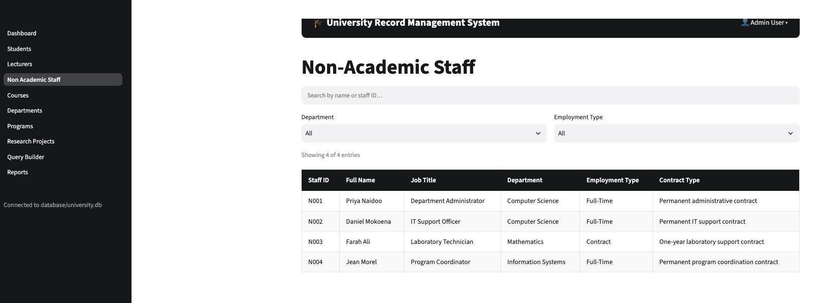
Figure A4. Non-academic staff page showing staff roles, departments and employment information.

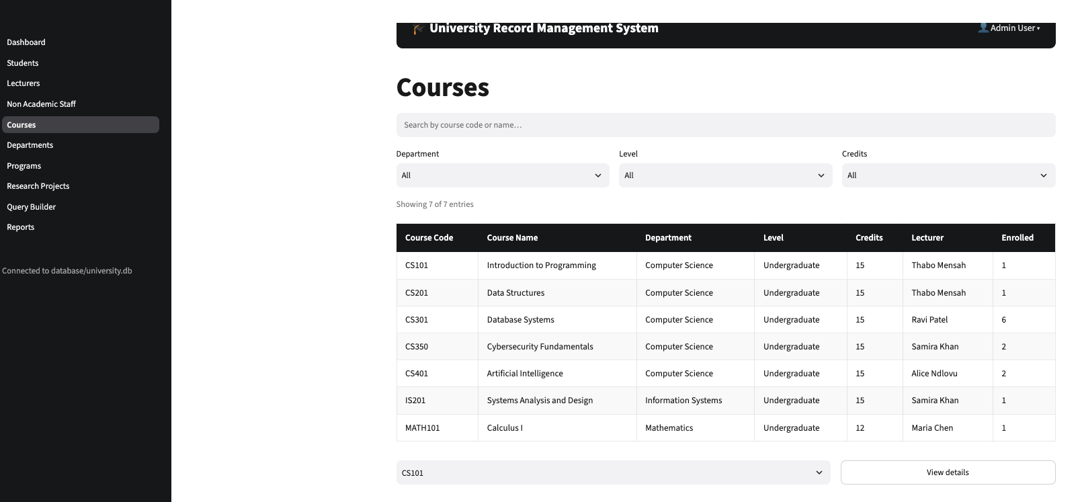
Figure A5. Courses page showing course code, department, level, credits, lecturer and enrolment count.

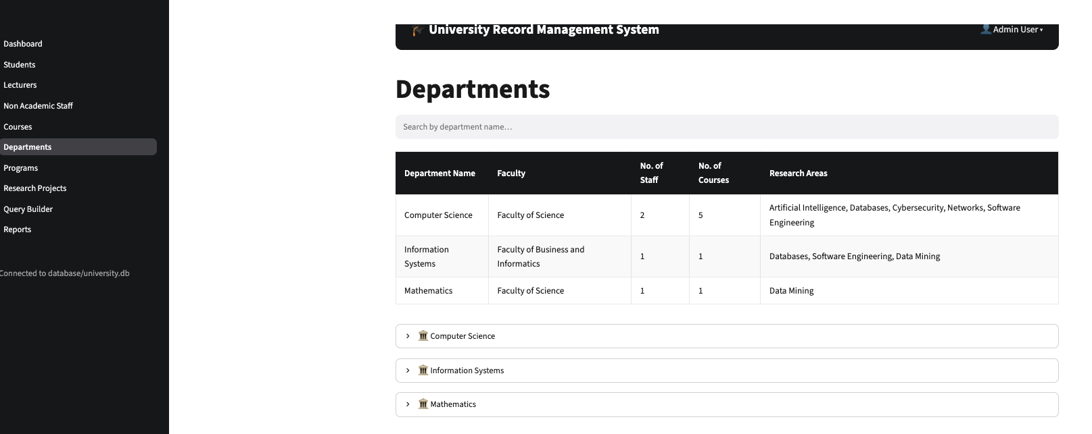
Figure A6. Departments page showing staff counts, course counts and research areas.

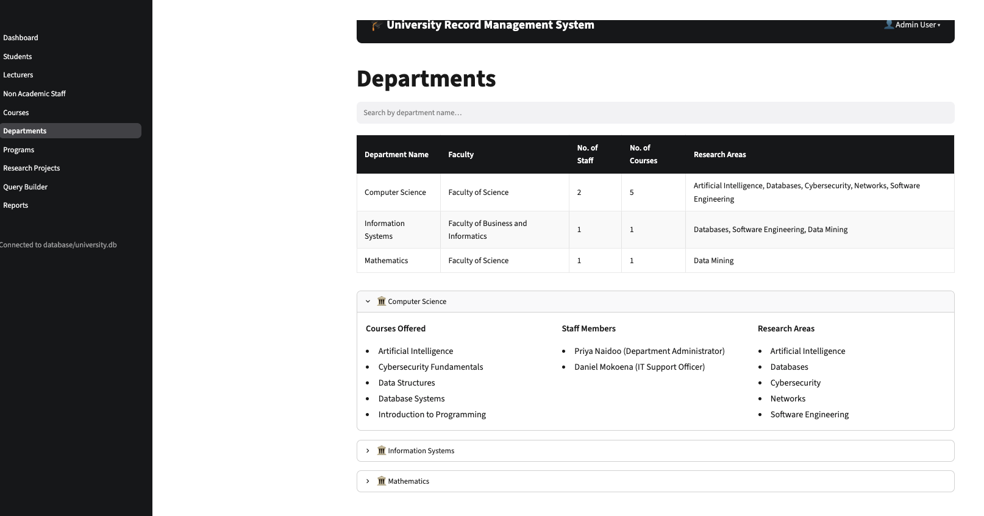
Figure A7. Department details expanded to show courses, staff members and research areas.

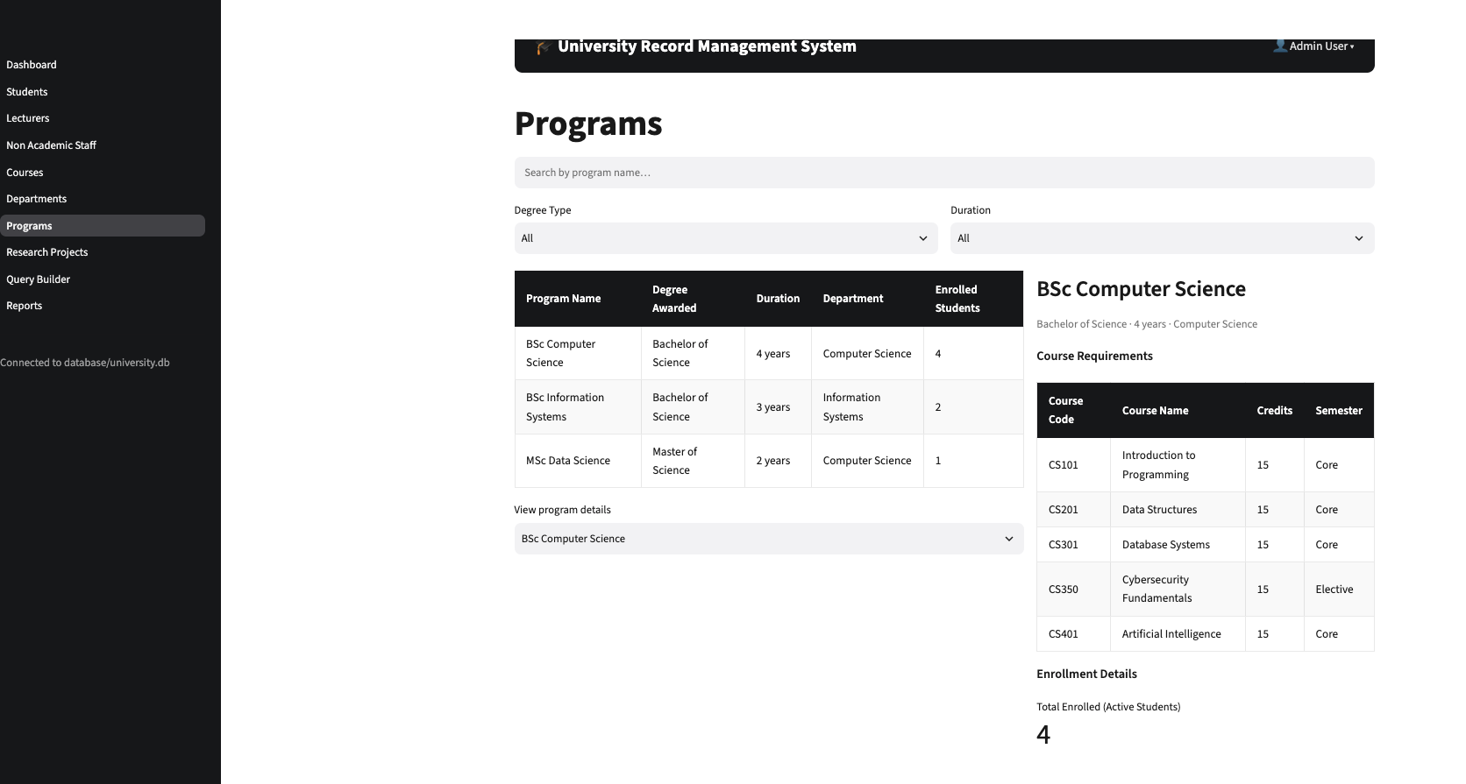
Figure A8. Programs page showing course requirements and enrolment details.

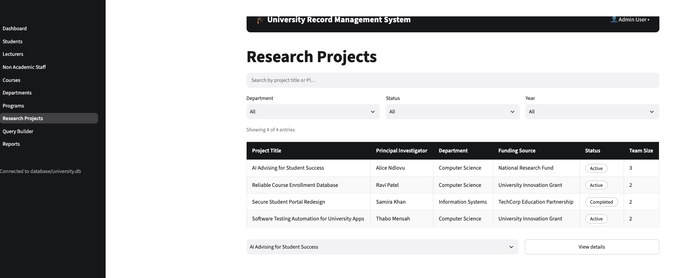
Figure A9. Research Projects page showing project title, principal investigator, funding source, status and team size.

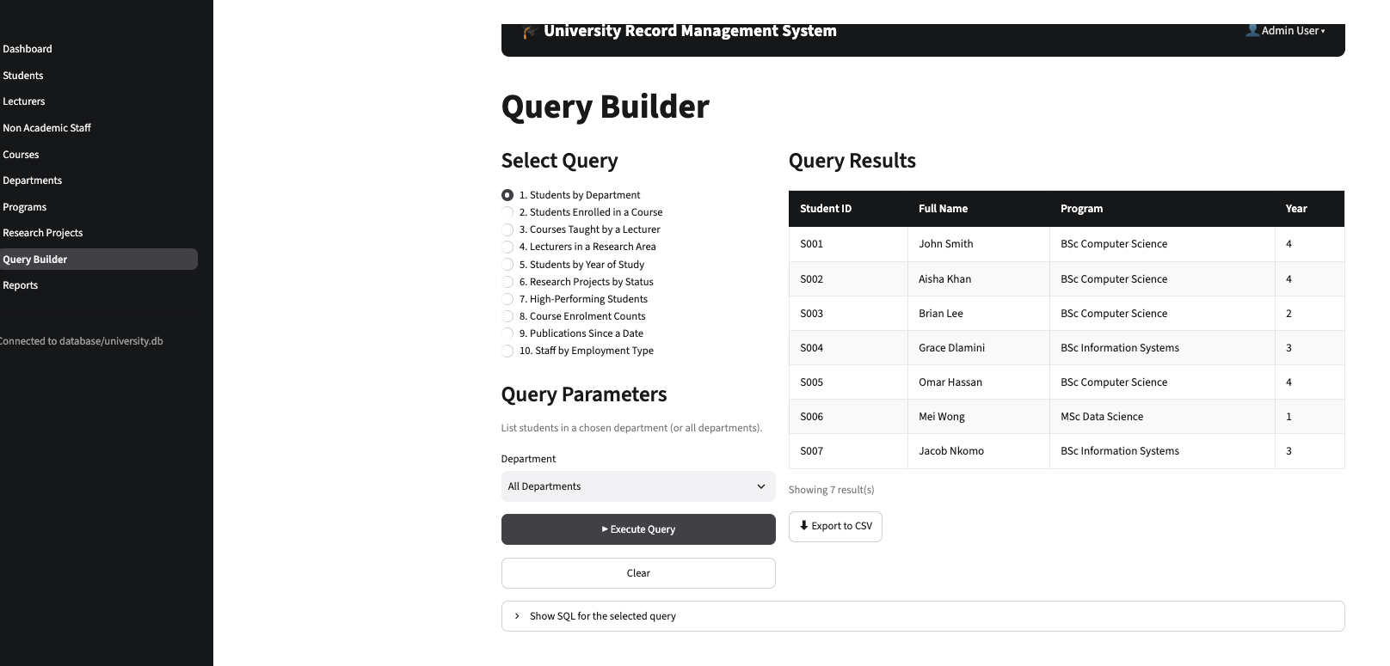
Figure A10. Query Builder: Students by Department query across all departments.

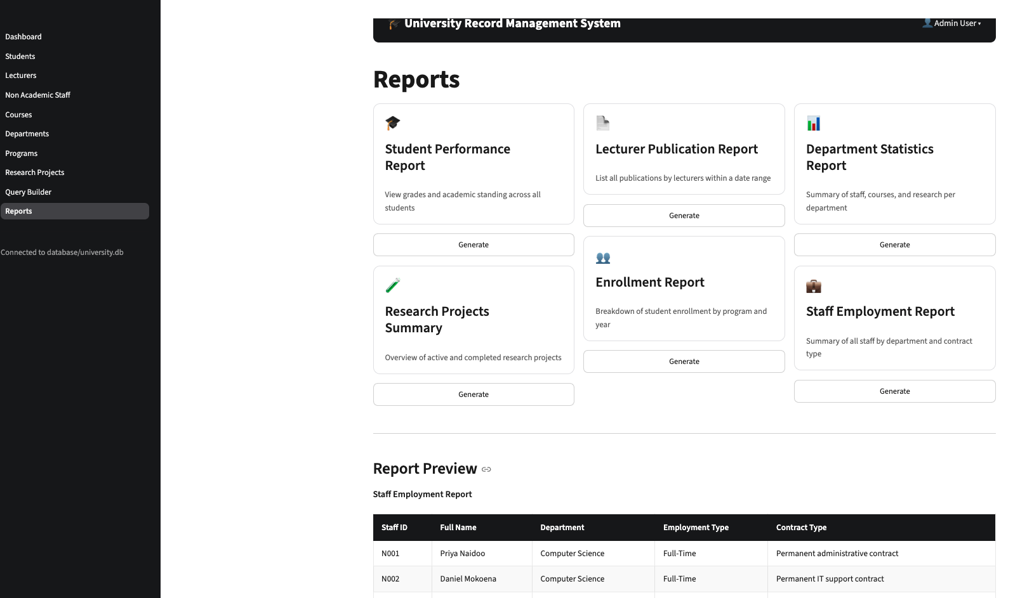
Figure A11. Reports page showing generated staff employment report preview.

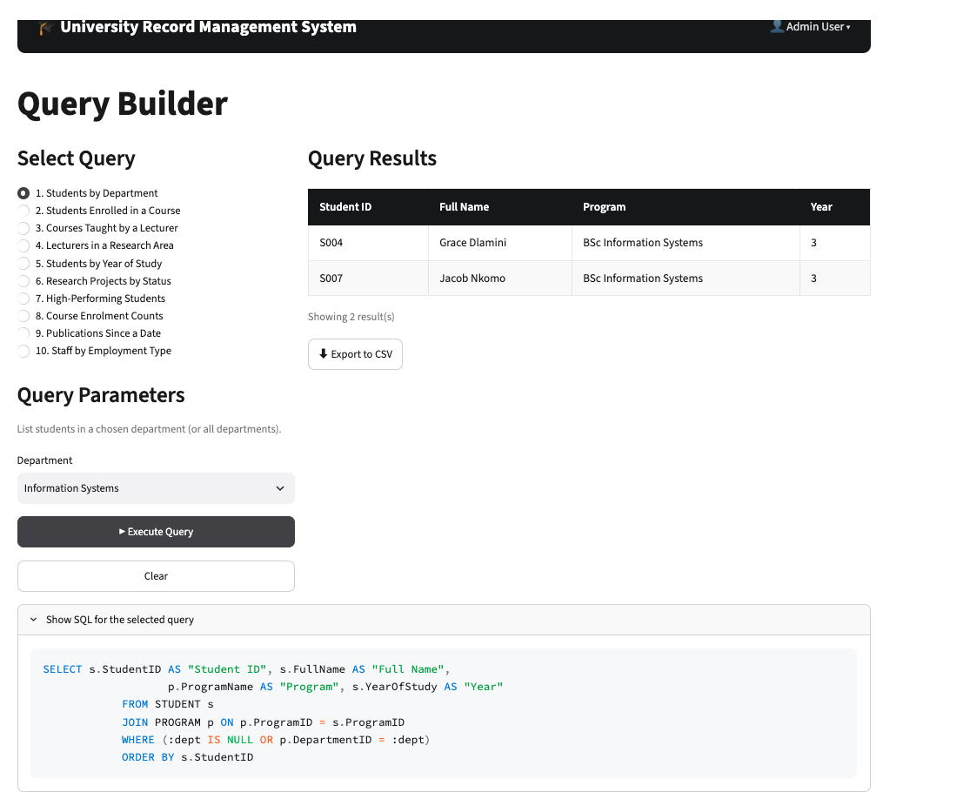
Figure A12. Query Builder: Students by Department query with Information Systems parameter and SQL statement exposed.

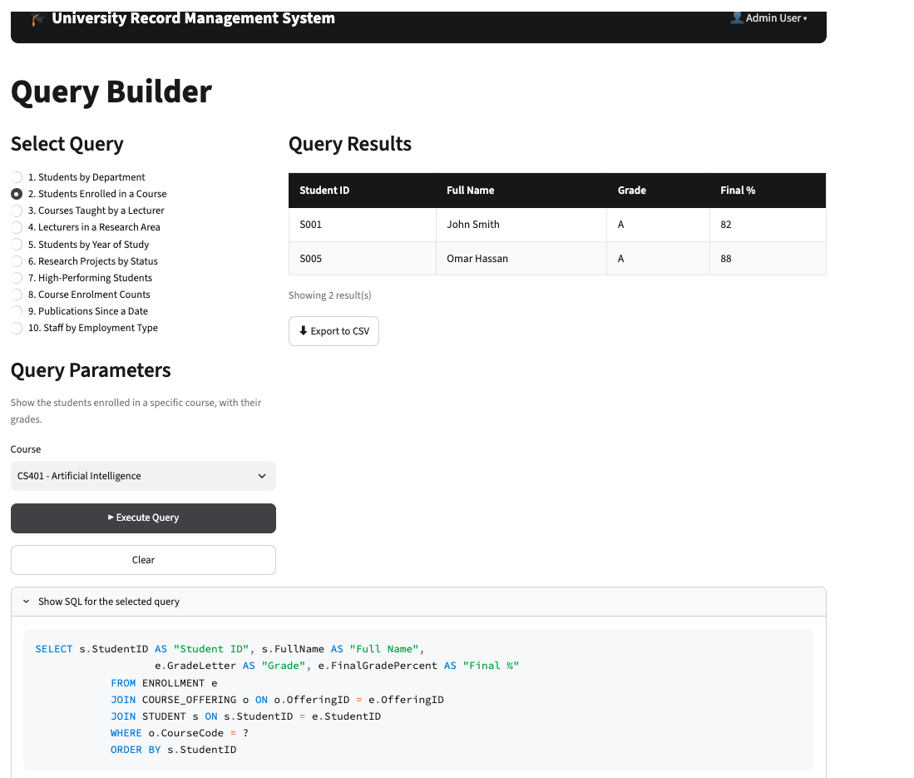
Figure A13. Query Builder: Students Enrolled in a Course query with grades and final percentage.

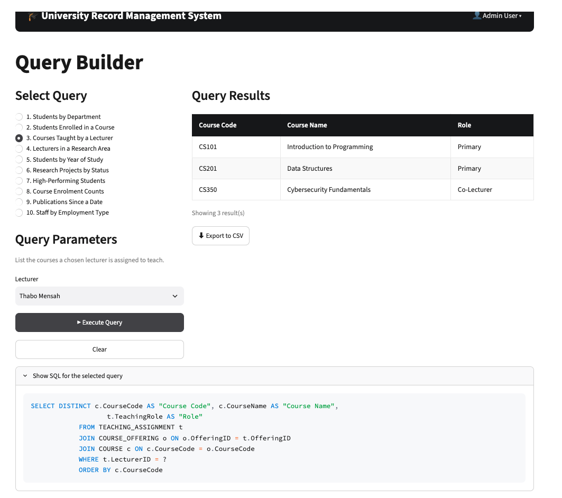
Figure A14. Query Builder: Courses Taught by a Lecturer query with teaching role.

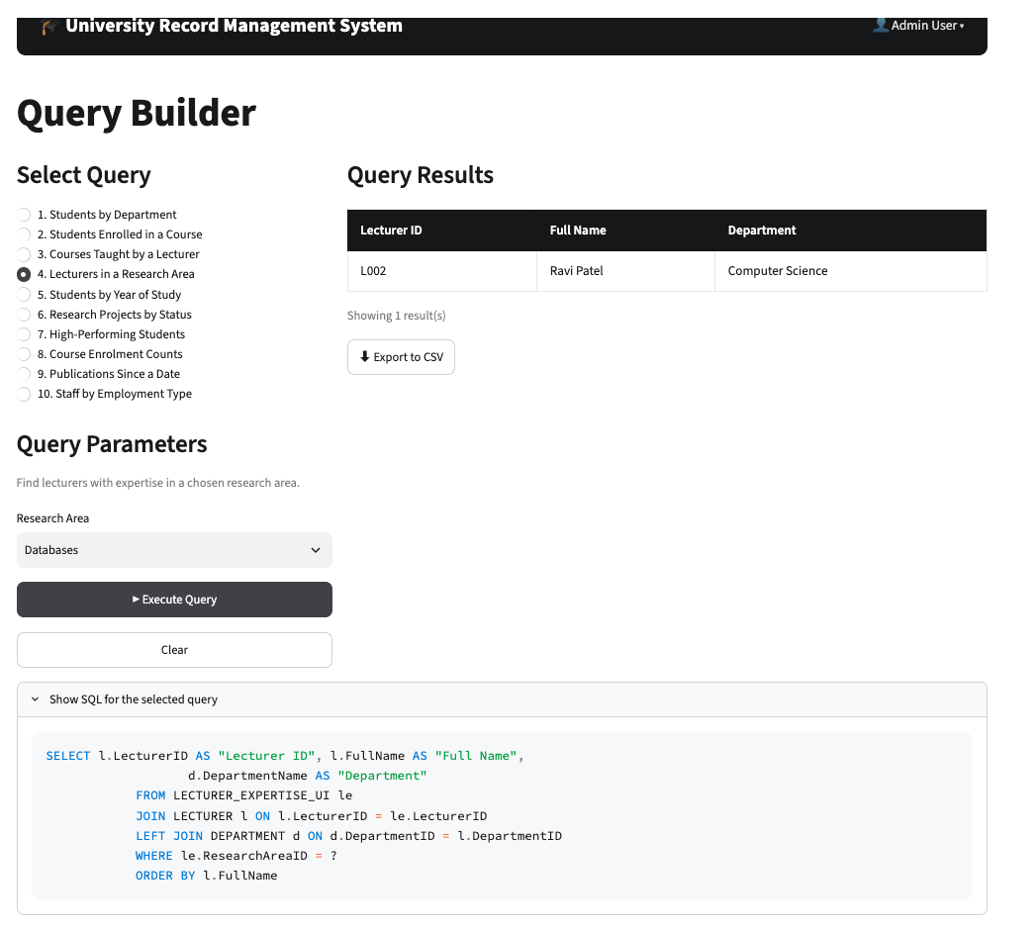
Figure A15. Query Builder: Lecturers in a Research Area query using research-area parameter.

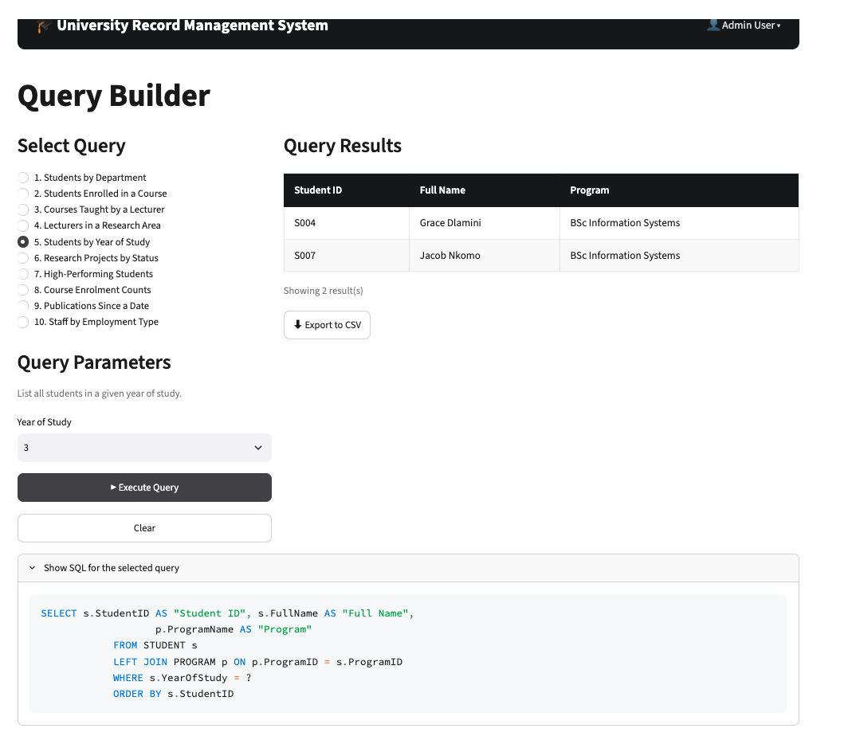
Figure A16. Query Builder: Students by Year of Study query with the SQL statement exposed.

Appendix B: Testing results
